Cairo University  
Faculty of Computers and Information



**CS251**

**Software Engineering I**

PlayZone

Software Design

3 wise Monkeys

Month & Year

Contents

Instructions [To be removed] 3

Team 3

Document Purpose and Audience 3

System Models 3

I. Class diagrams 3

Important Algorithm 5

II. Sequence diagrams 5

Class - Sequence Usage Table 7

Ownership Report 8

Policy Regarding Plagiarism: 8

# Github link……………………………………………………………………………………………………………………………………………………....8

# Team

|  |  |  |  |
| --- | --- | --- | --- |
| **ID** | **Name** | **Email** | **Mobile** |
| 20140205 | Karim Ashraf Mohammed | [Kareemallam_96@outlook.com](mailto:Kareemallam_96@outlook.com) | 01100896557 |
| 20140031 | Ahmed Alaa Hussein | ahmedalaahussein00@gmail.com | 01117730087 |
| 20140199 | Ghada Gamal Ramadan | sheblghada@gmail.com | 01152191535 |

# Document Purpose and Audience

**Target audience:**

**- Dr. Amr Kamel**

**- TA. Mohammed Samir**

**Document purpose:**

**This document is going to address the functional requirements in our website, it also will address the requirement elicitation.**

**It will also describe the actors and contents of the project.**

**This document is supposed to simplify the website for the reader, so that when the reader reads it he knows what the website is about.**

**It will also make it easier for us in the design phase.**

# System Models

## I. Class diagrams

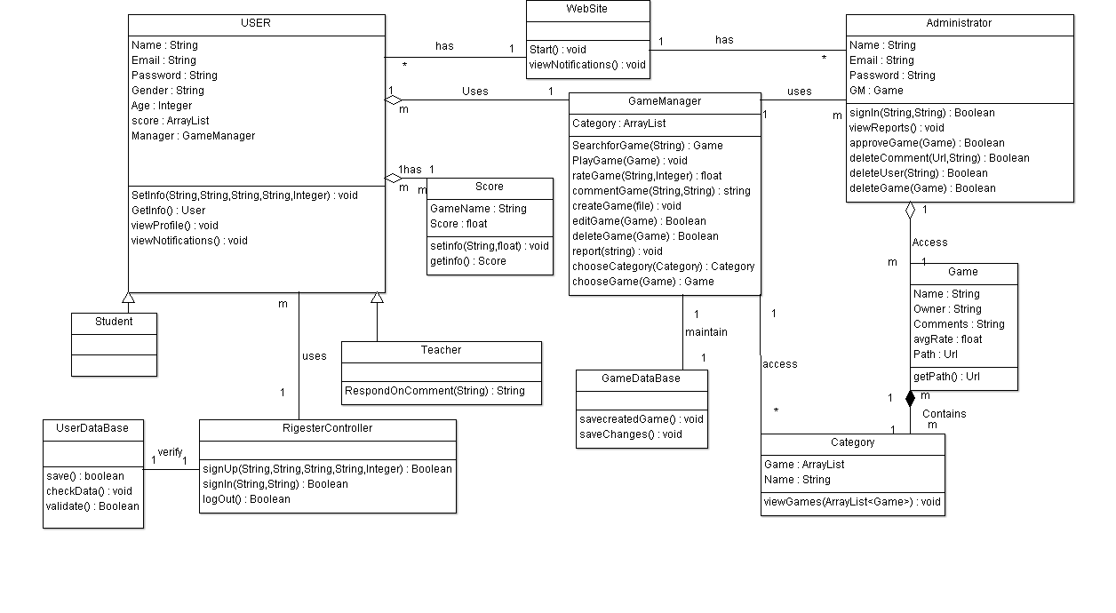

| **Class ID** | **Class Name** | **Description & Responsibility** |
| --- | --- | --- |
| 1 | Website | Interface class to make it easier for the user to use the website. |
| 2 | User | Actor |
| 3 | Administrator | Actor |
| 4 | Score | Calculates the score of the user for each game and saves it . |
| 5 | GameDataBase | Saves each created, edited or deleted game. |
| 6 | UserDataBase | Saves all the information of the users. |
| 7 | GameManager | Controls the website system from the aspect of gaming. |
| 8 | Registercontroller | Handles the registration operations and saves the data in the User's database. |
| 9 | Category | Classifies games into multiple categories |
| 10 | Game | Holds the information of each game inside the website. |
| 11 | Teacher | Actor that can create, delete or edit games. |
| 12 | Student | Actor that can perform regular user operations. |

### Important Algorithm

**none**

## II. Sequence diagrams

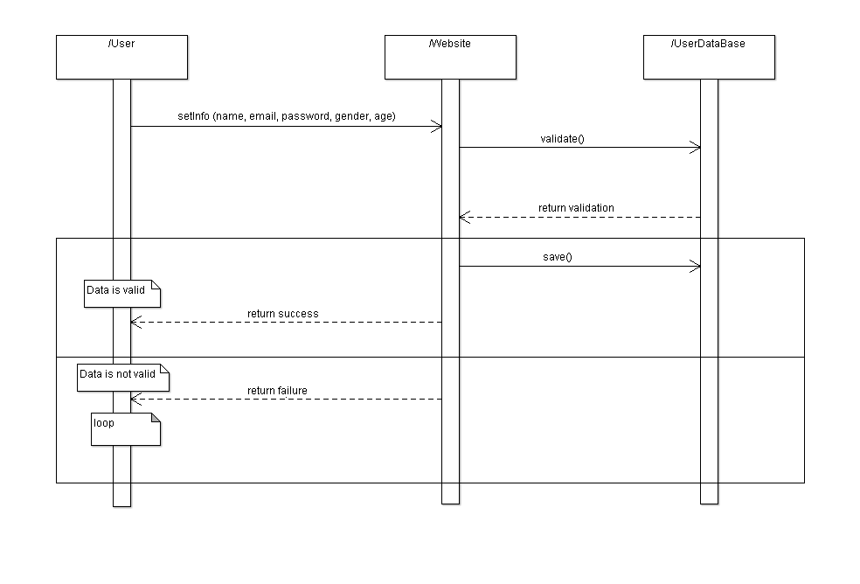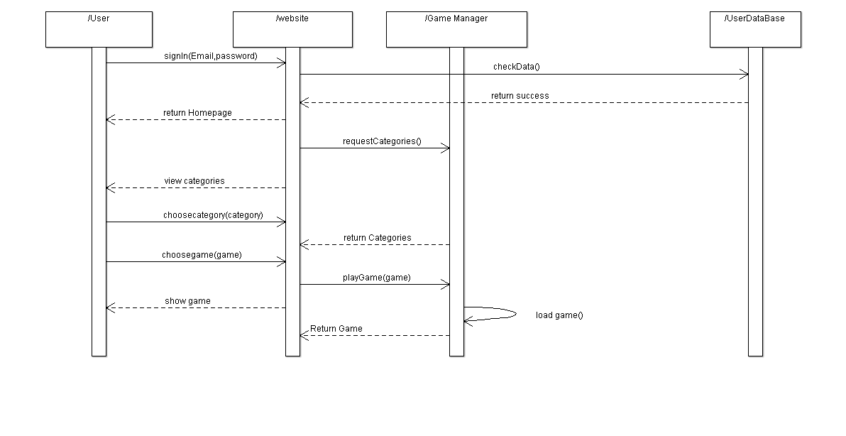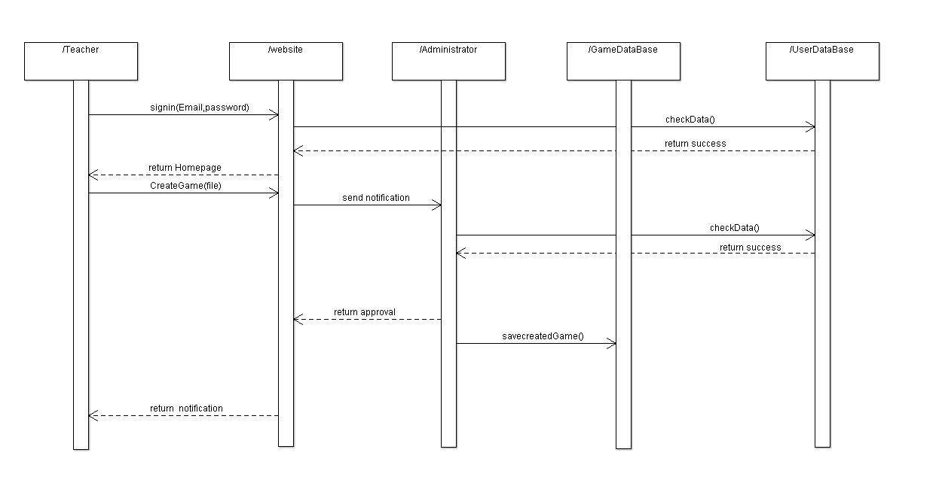

### Class - Sequence Usage Table

| **Class Name** | **Sequence Diagrams** | **Overall used methods** |
| --- | --- | --- |
| user | 1,2 | SetInfo, SignIn, Choose category, ChooseGame |
| userDataBase | 1,2,3 | Validate, Save , CheckData |
| gameDataBase | 3 | Savecreatedgame |
| Administrator | 3 | signIn , AprroveGame |

|  |  |
| --- | --- |
| **Item** | **Owners** |
| Documentation | *Ahmed Alaa* |
| Class Diagram | *Karim Ashraf* |
| Sequence Diagrams | *Ghada Gamal* |

# Github link